Index

Exercise 1: Booking Room 4

Task 1 - Create BookingRoom Project 4

Task 2 - Create Date Class 5

Task 3 - Create Time Class 5

Task 4 - Create BookingRoomClass 6

Task 5 - Write a Program class to accept and display information 8

Task 6 - Execute your program 10

Exercise 2: Project assignment 10

Task 1 - Create School Project 11

Task 2 - Create people package 11

Task 3 - Create Teacher class (people package) 11

Task 4 - Write code for Teacher class 12

Task 5 - Create Student class 13

Task 6 - Write code for Student class 13

Task 7 - Write Program Class in a different package, use classes in other package 15

Task 8 - Execute your program 16

1. Booking Room

In this exercise you will write a program to allow user books rooms in a hotel. This program will accept all information about rooms such as: check in date, check in time, number of rooms, room type and so on, and display this information to the user.

You have to create:

* BookingRoom Class to accept and display the information about booking room
* Date and Time Class to store information about check in date and check in time
* A program to demonstrate using above classes to accept and display information

Class diagram of the program:

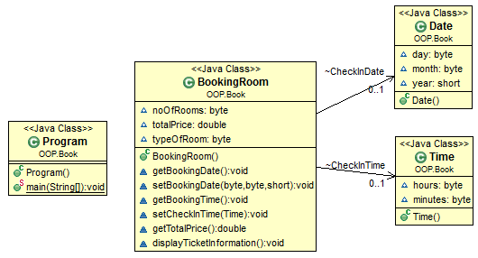

## Create BookingRoom Project

## Create Date Class

### Enter the following codes for Date Class

* 1. **public** **class** Date {
  3. **public** Date() {
  4. day = 0;
  5. month = 0;
  6. year = 0;
  7. }
  8. **byte** day;
  9. **byte** month;
  10. **short** year;
  12. }

## Create Time Class

* 1. **package** OOP.Book;
  2. **public** **class** Time {
  4. **public** Time() {
  5. hours = 0;
  6. minutes = 0;
  7. }
  8. **byte** hours;
  9. **byte** minutes;
  11. }

## Create BookingRoomClass

* 1. **public** BookingRoom() {
  2. CheckInDate = **new** Date();
  3. CheckInTime = **new** Time();
  4. }

### Variables for storing information about a booking

* 1. Date CheckInDate;
  2. Time CheckInTime;
  3. **byte** noOfRooms;
  4. **double** totalPrice;
  5. **byte** typeOfRoom;

### Method to display the date stored in instance variable booking date.

* 1. **void** getBookingDate() {
  2. System.*out*.println("Check in Date: " + CheckInDate.day + "/" + CheckInDate.month + "/" + CheckInDate.year);
  3. }

### Method to set instance variable booking date.

* 1. **void** setBookingDate(**byte** d, **byte** m, **short** y) {
  2. CheckInDate.day = d;
  3. CheckInDate.month = m;
  4. CheckInDate.year = y;
  5. }

### Method to display time stored in instance variable check in Time.

* 1. **void** getBookingTime() {
  2. System.*out*.println("Check in Time: " + CheckInTime.hours + ":" +
  3. CheckInTime.minutes);
  4. }

### Method to set the instance variable check in time.

* 1. **void** setCheckInTime(Time obj) {
  2. CheckInTime.hours = obj.hours;
  3. CheckInTime.minutes = obj.minutes;
  4. }

### Method to compute the total price of tickets booked.

* 1. **double** getTotalPrice() {
  2. **switch**(typeOfRoom) {
  4. **case** 1:
  5. totalPrice = noOfRooms * 1000;
  6. **break**;
  8. **case** 2:
  9. totalPrice = noOfRooms * 1500;
  10. **break**;
  12. **case** 3:
  13. totalPrice = noOfRooms * 1600;
  14. **break**;
  15. }
  16. **return** totalPrice;
  17. }

### Method to display all the information about the tickets booked.

* 1. **void** displayTicketInformation() {
  3. System.*out*.println("\nFollowing is the information about the room(s) booked: ");
  4. System.*out*.println("--------------------------------------------------------");
  6. getBookingDate();
  7. getBookingTime();
  9. System.*out*.println("Number of tickets: " + noOfRooms);
  10. System.*out*.print("Type of Room: ");
  12. **switch**(typeOfRoom) {
  14. **case** 1:
  15. System.*out*.print("Single");
  16. **break**;
  18. **case** 2:
  19. System.*out*.print("Double");
  20. **break**;
  22. **case** 3:
  23. System.*out*.print("Twin");
  24. **break**;
  25. }
  26. System.*out*.printf("\nTotal cost of the ticket: $%.2f", getTotalPrice());
  27. }
  29. }

## Write a Program class to accept and display information

### Import the Scanner Library

* 1. **import** java.util.Scanner;

### Create a main() method for executing the program

* 1. **public** **static** **void** main(String[] args) {
  2. **}**

### Code inside main() method:

* Create an instance of BookingRoom class
  1. BookingRoom objBookingRoom = **new** BookingRoom();
* Accept date of check in date in this hotel
  1. Scanner input = **new** Scanner(System.*in*);
  2. System.*out*.println("Enter check in date (mm dd yyyy): ");
  3. **byte** day = input.nextByte();
  4. **byte** month = input.nextByte();
  5. **short** year = input.nextShort();
* Set the check in date by passing primitive values to a method
  1. objBookingRoom.setBookingDate(day, month, year);
* Create an instance of Time class and store check in time in it
  1. Time objTime = **new** Time();
* Accept time of check in date in this hotel
  1. System.*out*.println("Enter check in time (hh mm): ");
  2. objTime.hours = input.nextByte();
  3. objTime.minutes = input.nextByte();
* Set the checkin time by passing an object to a method
  1. objBookingRoom.setCheckInTime(objTime);
* Accept and set the type of room
  1. System.*out*.println("Enter the type of room: \n1. Single\n2. Double\n3. Twin\n");
  2. objBookingRoom.typeOfRoom = input.nextByte();
* Accept and set the number of tickets
  1. System.*out*.println("Enter the number of rooms: ");
  2. objBookingRoom.noOfRooms = input.nextByte();
* Display the ticket information
  1. objBookingRoom.displayTicketInformation();

## Execute your program

* 1. 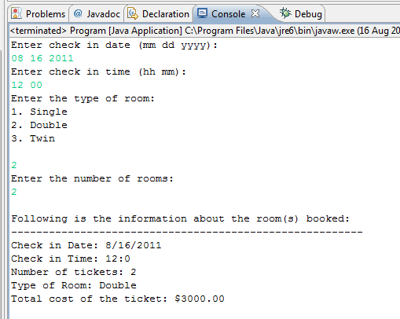

Project assignment

In this exercise, you will write a program to help an Administrator in a school accept information about student (name, age, address, project which they want to do, etc) and teacher (code, name, address, etc). This program also allow assign a student with a teacher who he/she want to work with

Class diagram are shown below:

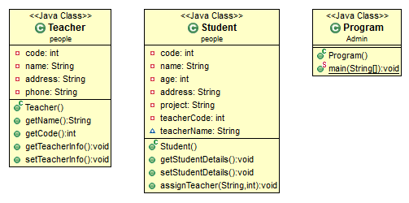

## Create Teacher class (people package)

### Constructor

* 1. **public** Teacher() {
  2. code = 0;
  3. name = "";
  4. address = "";
  5. phone = "";

}

### Instance variable to store teacher information

* 1. **private** **int** code;
  3. /** Instance variable to store teacher name. */
  4. **private** String name;
  6. /** Instance variable to store the address of the teacher. */
  7. **private** String address;
  9. /** Instance variable to store phone number of the teacher. */

**private** String phone;

### Method to retrieve the teacher name.

* 1. **public** String getName() {
  2. **return** name;
  3. }

### Method to retrieve the teacher code.

* 1. **public** **int** getCode() {
  2. **return** code;
  3. }

### Method to display the teacher information.

* 1. **public** **void** getTeacherInfo() {
  2. System.*out*.println("The details about the teacher are:");
  3. System.*out*.println("Code: " + code);
  4. System.*out*.println("Address: " + address);
  5. System.*out*.println("Phone Number: " + phone);
  6. }

### Method to accept the details about a teacher.

* 1. **public** **void** setTeacherInfo() {
  3. Scanner input = **new** Scanner(System.*in*);
  5. System.*out*.println("Enter details about the teacher:");
  6. System.*out*.println("Enter teacher's code:");
  7. code = input.nextInt();
  8. input.nextLine();
  9. System.*out*.println("Enter name:");
  10. name = input.nextLine();
  11. System.*out*.println("Enter address:");
  12. address = input.nextLine();
  13. System.*out*.println("Enter phone number:");
  14. phone = input.nextLine();
  15. }

## Write code for Student class

### Constructor

* 1. **public** Student() {
  2. code = age = 0;
  3. name = "";
  4. address = "";
  5. project = "";
  6. teacherCode = 0;
  7. teacherName = "";
  8. }

### Instance variable to store student information

* 1. **private** **int** code;
  2. **private** String name;
  3. **private** **int** age;
  4. **private** String address;
  5. **private** String project;
  6. **private** **int** teacherCode; //store code of the teacher who student want to work with
  7. String teacherName; //store name of the teacher who student want to work with
  8. }

### Method to display the details of Student.

* 1. **public** **void** getStudentDetails() {
  2. System.*out*.println("The details about the student are:");
  3. System.*out*.println("Code: " + code);
  4. System.*out*.println("Age: " + age);
  5. System.*out*.println("Address: " + address);
  6. System.*out*.println("Project: " + project);
  7. System.*out*.print("Teacher attending the student: " + teacherName);
  8. }

### Method to accept the details of Student.

* 1. **public** **void** setStudentDetails() {
  2. Scanner input = **new** Scanner(System.*in*);
  3. System.*out*.println("Enter details about the student:");
  4. System.*out*.println("Enter student code:" );
  5. code = input.nextInt();
  6. System.*out*.println("Enter name:");
  7. name = input.next();
  8. System.*out*.println("Enter age:" );
  9. age = input.nextInt();
  10. System.*out*.println("Enter address:");
  11. address = input.next();
  13. System.*out*.println("Enter Project: You can type as many lines as " +
  14. "you wish. Enter 0 to stop.");
  15. // Accept the details about various project until the user types a zero
  16. project = **new** Scanner(System.*in*).useDelimiter("0").next();
  17. }

### Method to assign a teacher to a student.

* 1. **public** **void** assignTeacher(String name, **int** code) {
  2. **this**.teacherName = name;
  3. **this**.teacherCode = code;
  4. }

## Write Program Class in a different package, use classes in other package

### Create a Admin package

### Create Program Class belong to Admin package

### Import 2 class Student and Teacher

* 1. **import** people.Student;
  2. **import** people.Teacher;

### Write code for main() method in Program Class

* 1. **public** **static** **void** main(String[] args) {
  3. // Create a new teacher
  4. Teacher objTeacher = **new** Teacher();
  5. // Accept details about the teacher
  6. objTeacher.setTeacherInfo();
  8. // Create a new Student
  9. Student objStudent = **new** Student();
  10. // Accept student details
  11. objStudent.setStudentDetails();
  13. // Assign a teacher to the student
  14. objStudent.assignTeacher(objTeacher.getName(), objTeacher.getCode());
  16. // Display the student details
  17. objStudent.getStudentDetails();
  19. }

## Execute your program

* 1. 